**How to make a stick insect, grasshopper or cricket**

**Materials**

* Stick,
* 3 pipe cleaners,
* 2 googly eyes or paper eyes

**Optional**

* Paper or fabric for wings

**How to make**

1. Choose a stick.
2. Take each pipe cleaner in turn and wrap it around your chosen stick, cross over and twist each pipe cleaner to secure.
3. Fold the end of each pipe cleaner to make feet and help your insect stand up.
4. Glue on your googly eyes.

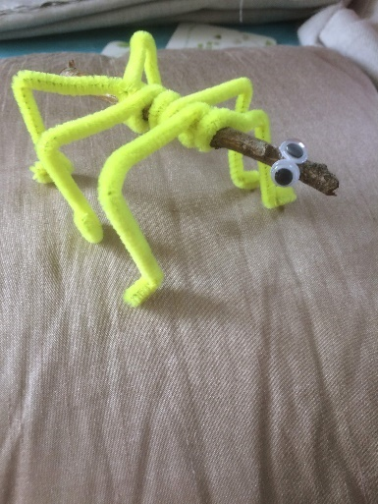

**Optional**

If you want to make a cricket or grasshopper draw two paper wings and fasten to your insects back.