**How to make a twig butterfly or dragonfly**

**Materials**

* Twig
* Net, material, or chiffon,
* Ribbon
* Pom pom
* Googly eyes

**How to make**

1. Select a twig.
2. Cut two rectangles of net, material or chiffon to make wings.
3. Tie a ribbon around the middle.
4. Glue the ribbon onto the twig.
5. Glue a pom pom onto the twig for a head.
6. Add some googly eyes.

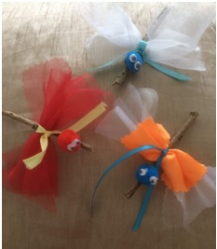

**Your twig insect is complete.**